1. INTRODUCTION OBJECTIVE
1.1 Introduction

We have developed the website “Tanishq jewellery” for “Home Project”.
Tanishq jewellery is an online jewellery store that houses high quality jewellery with strikingly exquisite designs. With its affordable rates and unique shopping experience, Bluestone is your one stop destination for making any given day an occasion.
That's precisely what you can expect at Tanishq.com. An online jewellery store that's positioned to cater to stylish men and women, Tanishq houses exquisite pieces of jewellery, designed to appeal to people with unique tastes.
Tanishq jewellery aims at revolutionizing the Jewellery and Lifestyle Ecommerce scene in India with its firm focus on affordability, quality and user experience.

1.2 Objective
- Easy maintenance of records
- Time saving system
- Online booking
- Errorless solution
- Capability of handling thousands
- Security of transaction

(A)Existing System
In a jewellery shop, the existing system typically refers to the current processes, procedures and technologies in place for managing inventory, sales, customer relationships, and other aspects of the business. This might include manual record-keeping, traditional point-of –sales systems, security measures, and any other tools or methods used to run the shop efficiently.

Advantages
- Customer can browse and shop for jewellery from the camfort of there homes, anytime and anywhere.
- Online shops often offer a wider selection of jewellery items compared to physical stores, allowing customers to explore a diverse range of styles and designs.
- Online jewellery shops enable customers to access product from around the world, expanding their options beyond local stores.
- Customers can easily compare prices, styles, and reviews of different jewellery pieces to make informed purchasing decisions.

Disadvantages
- This system is long Time consuming.
- Product cannot compare with each other this is main drawback of current system.
- This system very expensive.
- User cannot update that profile.
- In this system online payment option is available credit card, debit card, net banking.

2. SYSTEM ANALYSIS
System analysis is the process of examining a business situation for the purpose of developing a system solution to a problem or devising improvements to such a situation. Before the development of any system can begin, a project proposal is prepared by the users of the potential system and/or by systems analysts and submitted to an appropriate managerial structure within the organization.

2.1 Identification of need:
Assuming that a new system is to be developed, the next phase is a system analysis. Analysis involved a detailed study of the current system, leading to specifications of a new system. Analysis is a detailed study of various operations performed by a system and their relationship with in and outside the system. During analysis, data are collected on the available files, decision points and transactions handled by the present system. Interviews, on-site observation and questionnaire are the tools used for system analysis. Using the following step it becomes easy to draw the exact boundary of the new system under consideration.
2.2 Preliminary Investigation
All procedures, requirement must be analysed and documented in the form of detailed data flow diagrams, data dictionary, logical data structures and miniature specifications. System analysis also includes sub-dividing of complex process involving the entire system, identifiers of data stores and manual processes.
The main points to be discussed in system analysis are .Specification of what the new system is to accomplish based on the user requirements.
Functional hierarchy showing the function to be performed by the new system and their relationship with each other.

3. FEASIBILITY STUDY
The feasibility study investigates the problem and the information needs of the stakeholders. It seeks to determine the resources required to provide an information systems solution, the cost and benefits of such a solution, and the feasibility of such a solution. The analyst conducting the study gathers information using a variety of methods, the most popular of which are:
- Interviewing users, employees, managers, and customers.
- Developing and administering questionnaires to interested stakeholders, such as potential users of the information system.
- Observing or monitoring users of the current system to determine their needs as well as their satisfaction and dissatisfaction with the current system.
- Collecting, examining, and analyzing documents, reports, layouts, procedures, manuals, and any other documentation relating to the operations of the current system.
- Modeling, observing, and simulating the work activities of the current system.
The goal of the feasibility study is to consider alternative information systems solutions, evaluate their feasibility, and propose the alternative most suitable to the organization. The feasibility of a proposed solution is evaluated in terms of its components.

3.1 Technical Feasibility
The economic viability of the proposed system. The proposed project's cost and benefits are evaluated. Tangible costs include fixed and variable costs, while tangible benefits include cost savings, increased revenue, and increased profit. A project is approved only if it covers its cost in a given period of time. However, a project may be approved only on its intangible benefits such as those relating to government regulations, the image of the organization, or similar considerations
3.2 Economical Feasibility
The possibility that the organization has or can procure the necessary resources. This is demonstrated if the needed hardware and software are available in the marketplace or can be developed by the time of implementation.

3.3 Operational feasibility
The ability, desire, and willingness of the stakeholders to use, support, and operate the proposed computer information system. The stakeholders include management, employees, customers, and suppliers. The stakeholders are interested in systems that are easy to operate, make few, if any, errors, produce the desired Information, and fall within the objectives of the organization.

4. HARDWARE& SOFTWARE REQUIREMENT SPECIFICATIONS

- Hardware Requirement

Server Side : Hard Disk Drive 1 TB
RAM 8 GB Higher
Processor Intel(R) Core(TM) i5-8350U CPU @ 1.70GHz 1.90
GHz

Client Sidse : Hard Disk Drive 32 GB OR Higher
RAM 4 GB Higher

- Software Requirement

Server Side : Software Notpad++, vs code
Operating System Windows 11 pro
Front end HTML, PHP, Css, Javascript
Back end My SQL, PHP

Client Side : Software Any browser
Operating system Window 7, Android and above

5. SYSTEM DESIGN

CONTAX LEVEL DFD (0.level)

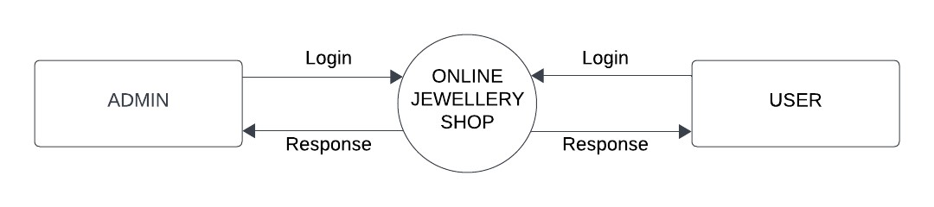

FIRST LEVEL FOR USER SIDE:
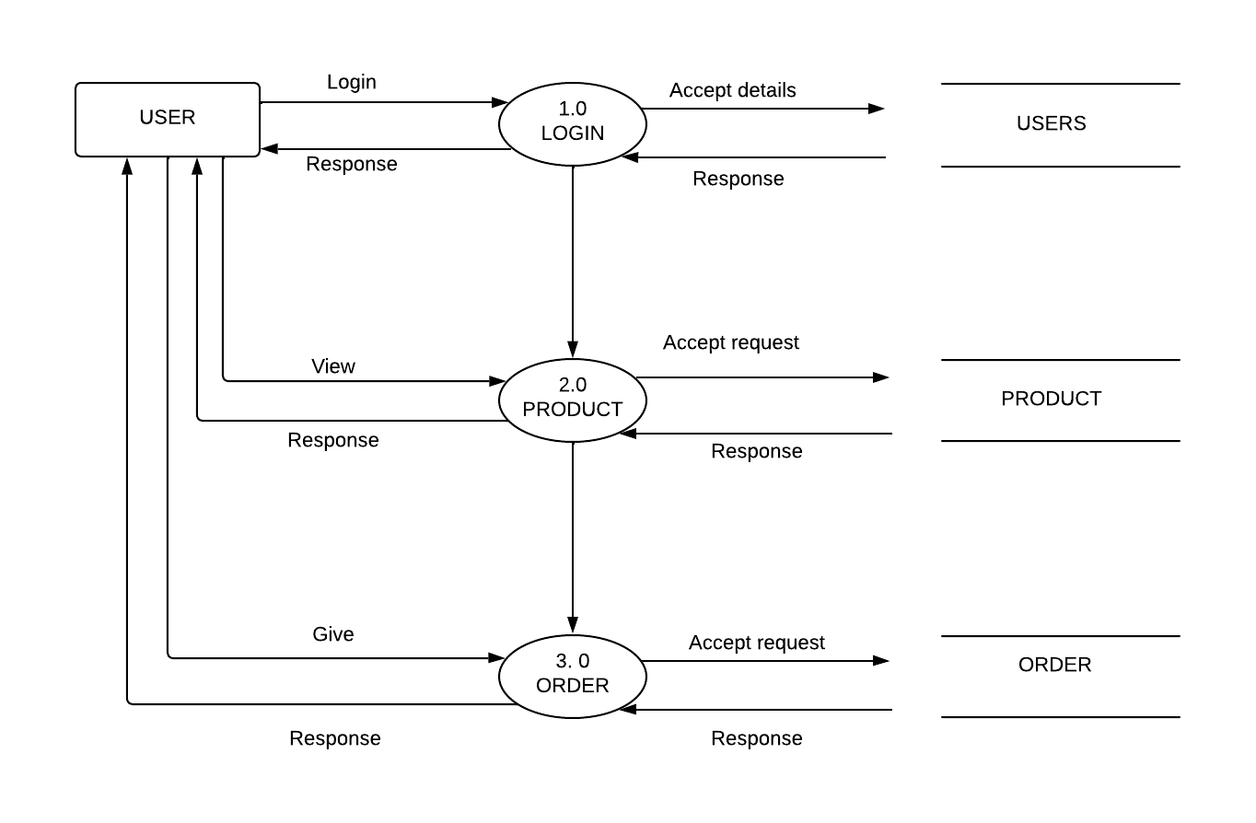

FIRST LEVEL DFD FOR ADMIN :
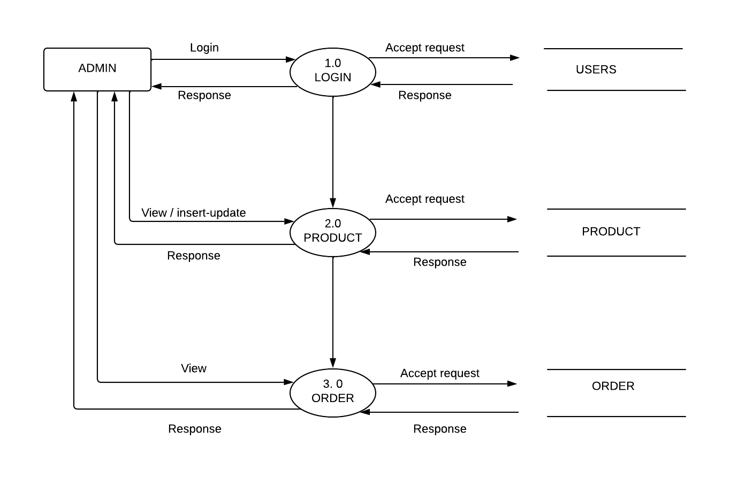

E-R DIGRAM:
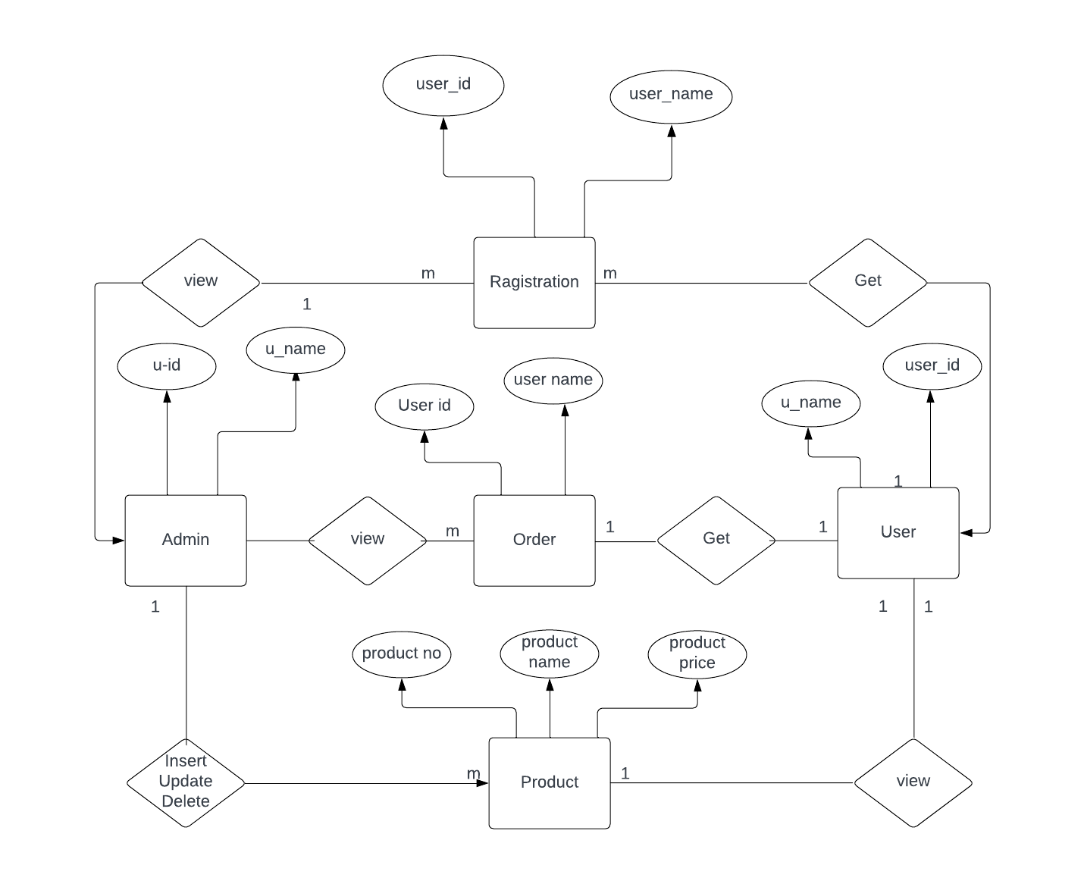

5.2 MODULES AND THEIR DESCRIPTION
1. Admin
2. Customer

- Admin
- Admin is a creator of this site.
- Admin is insert, delete, search, update the product.
- Admin is tack the order list and sent the jewellery to customer.
- It is also manage the full site.
- It is also add and delete the take customer.
- It is take the feedback of the customer.

- Customer
- Customer is search the jewelleries.
- Customer is one who will purchase the jewellery.
- It is give the feedback to admin.
- It is create a new account.

TABLE DETAILS s(DATA DICTIONARY

USERS TABLE :

Field Name | Field type | Size | Constraint | Description
id | Int | 11 | Primary key | Store id
Fname | Varchar | 50 | Not null | Store fname
Lname | Varchar | 50 | Not null | Store lname
Address | varchar | 100 | Not null | Store address
City | Varchar | 100 | Not null | Store city
Pin | Int | 6 | Not null | Store pin
email | Varchar | 100 | Not null | Store email
Password | Varchar | 15 | Not null | Stor pass
Type | Varchar | 20 | Not null | Store type

PRODUCT TABLE:

Field Name | Field type | Size | Constraint | Description
id | Int | 11 | Primary key | Store id
Product code | Varchar | 60 | Not null | Store product code
Product name | Varchar | 60 | Not null | Store product name
Product desc | Varchar | 70 | Not null | Store product details
Product img name | Varchar | 60 | Not null | Store product img
Qty | Int | 5 | Not null | Store quntity
Price | decimal | 10,2 | Not null | Store product price

Order table:

Field Name | Field type | Size | Constraint | Description
id | Int | 15 | Primary key | Store id
Product code | Varchar | 50 | Not null | Store product code
Product name | Varchar | 50 | Not null | Store product name
Product desc | Varchar | 50 | Not null | Store product desc
Price | Int | 10 | Not null | Store price
Units | Int | 5 | Not null | Store units
Total | Int | 15 | Not null | Store total
Date | Timestamp |  | Not null | Store date
Email | Varchar | 50 | Not null | Store email

5.4 SCREEN SHOT

PAGES :
1. HOME PAGE :
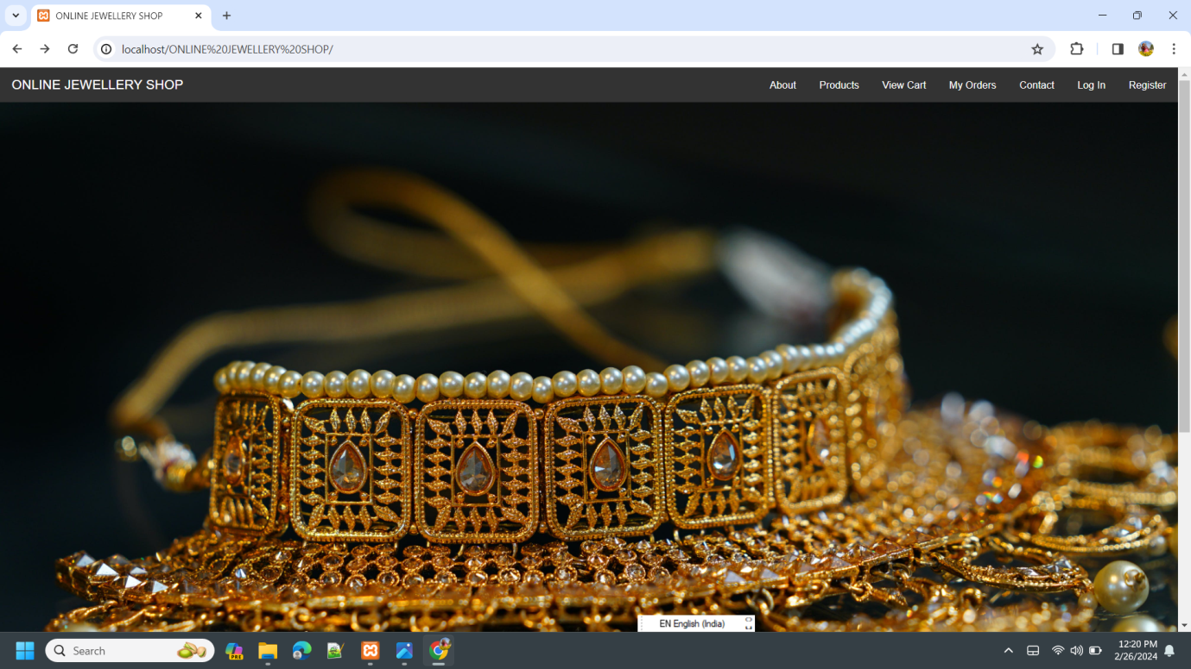

2. REGISTRATION PAGE :
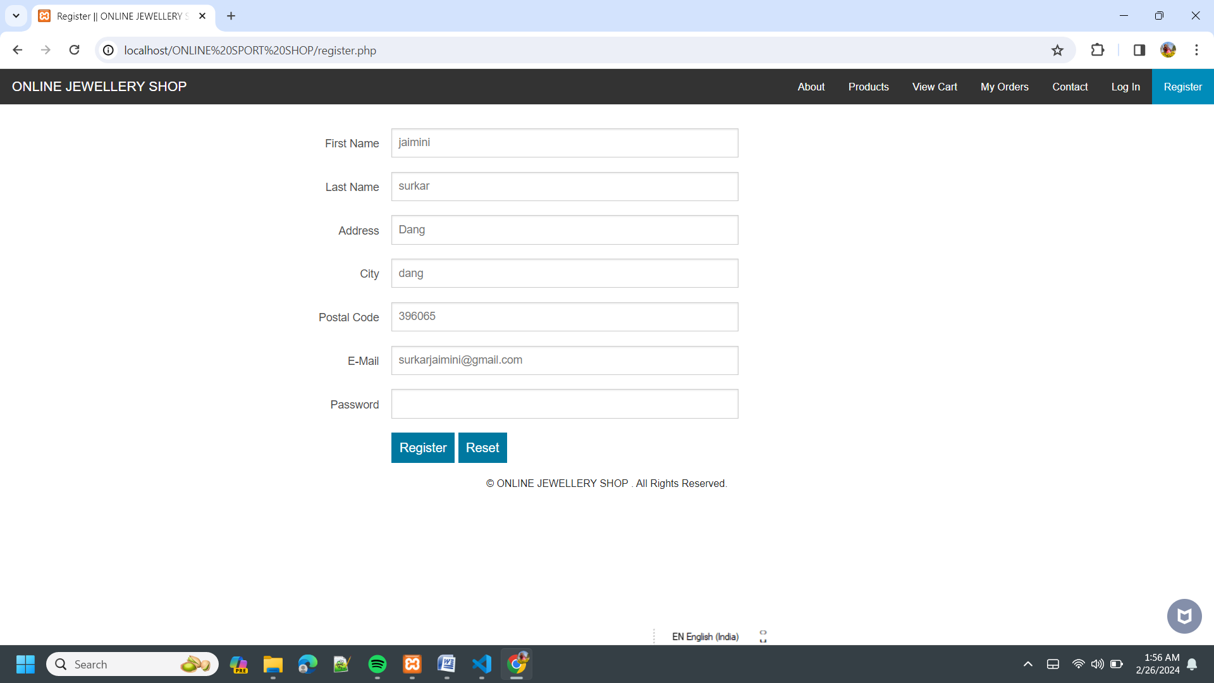

3. LOGIN PAGE :
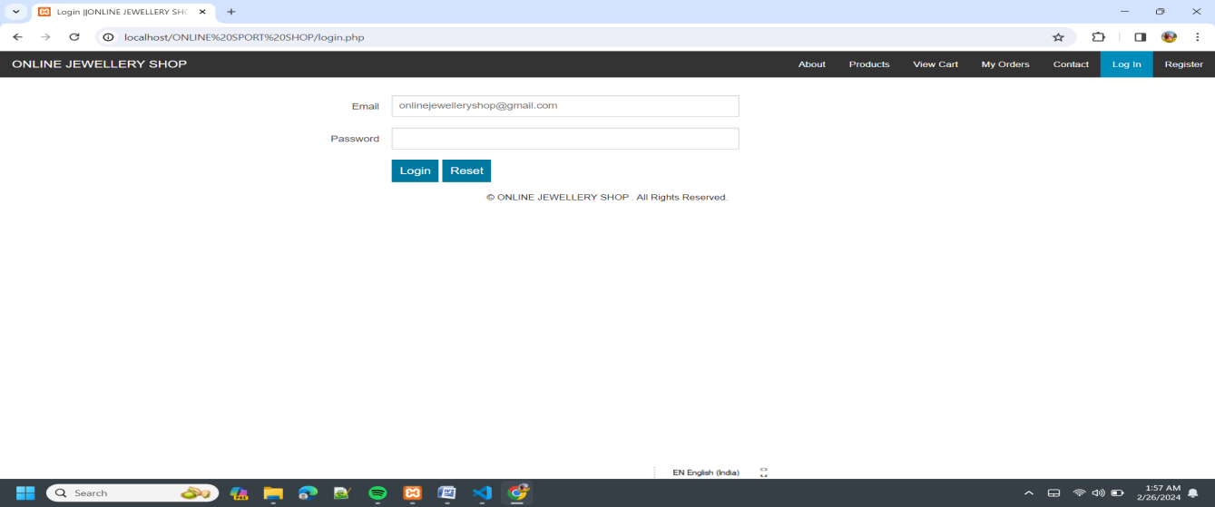

4. CONTACT PAGE :
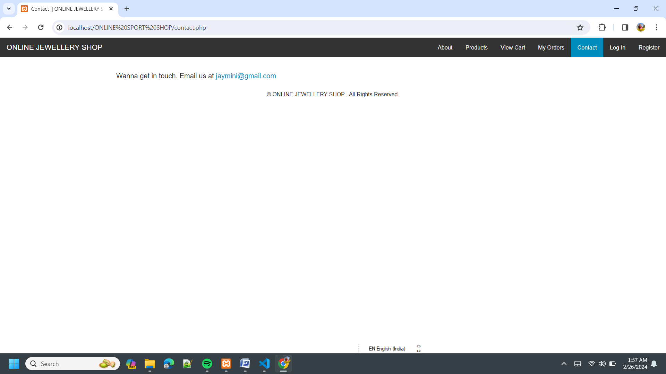

5. PRODUCT PAG :
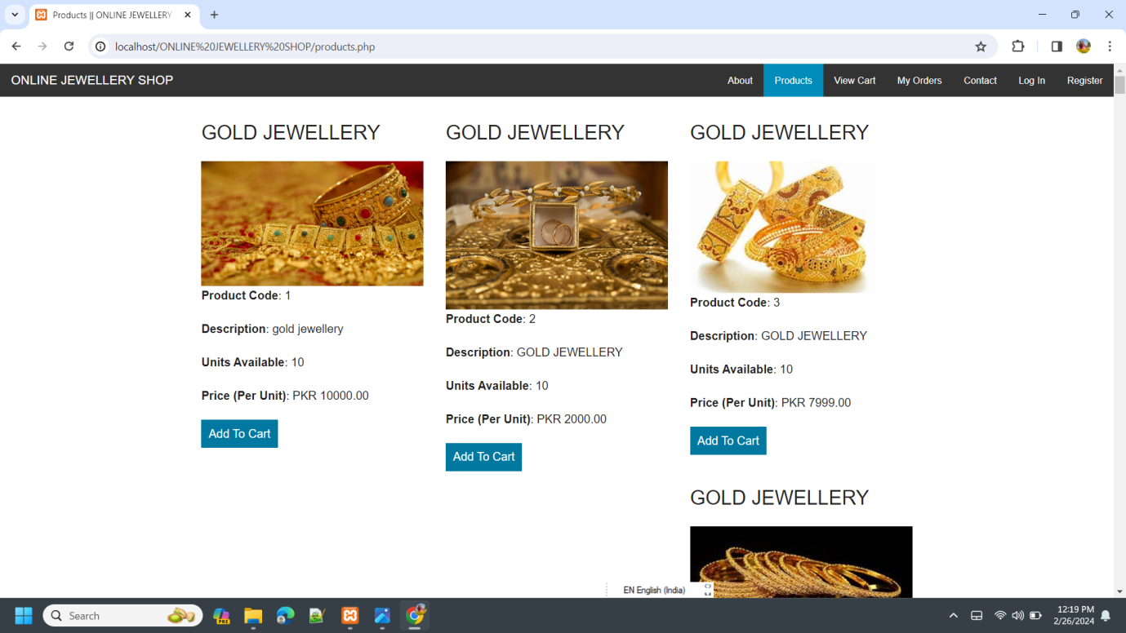

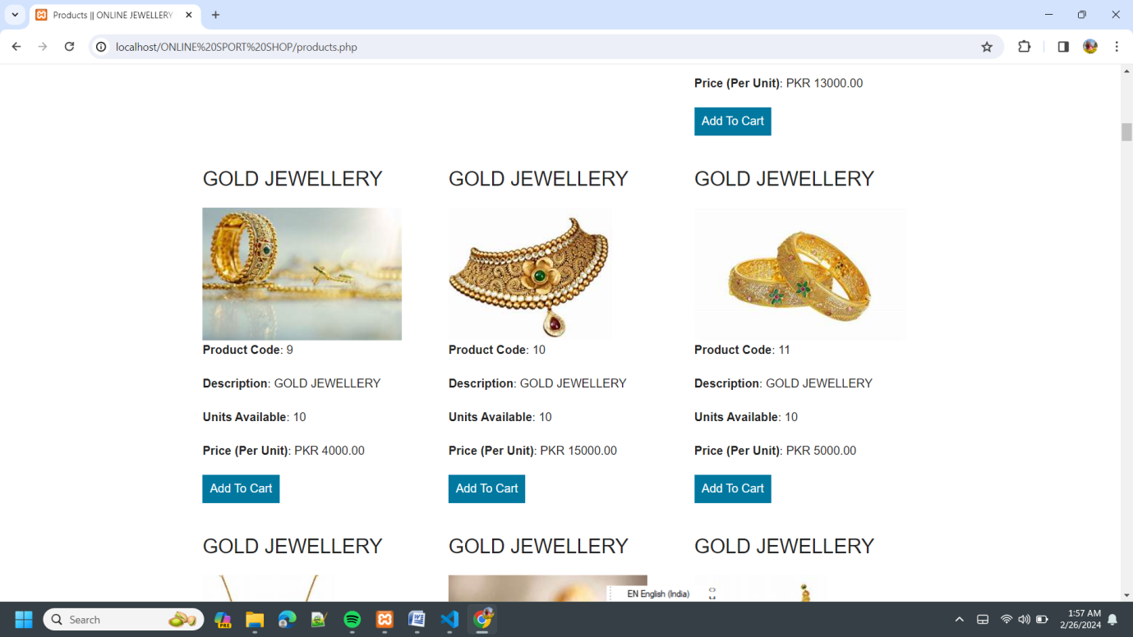

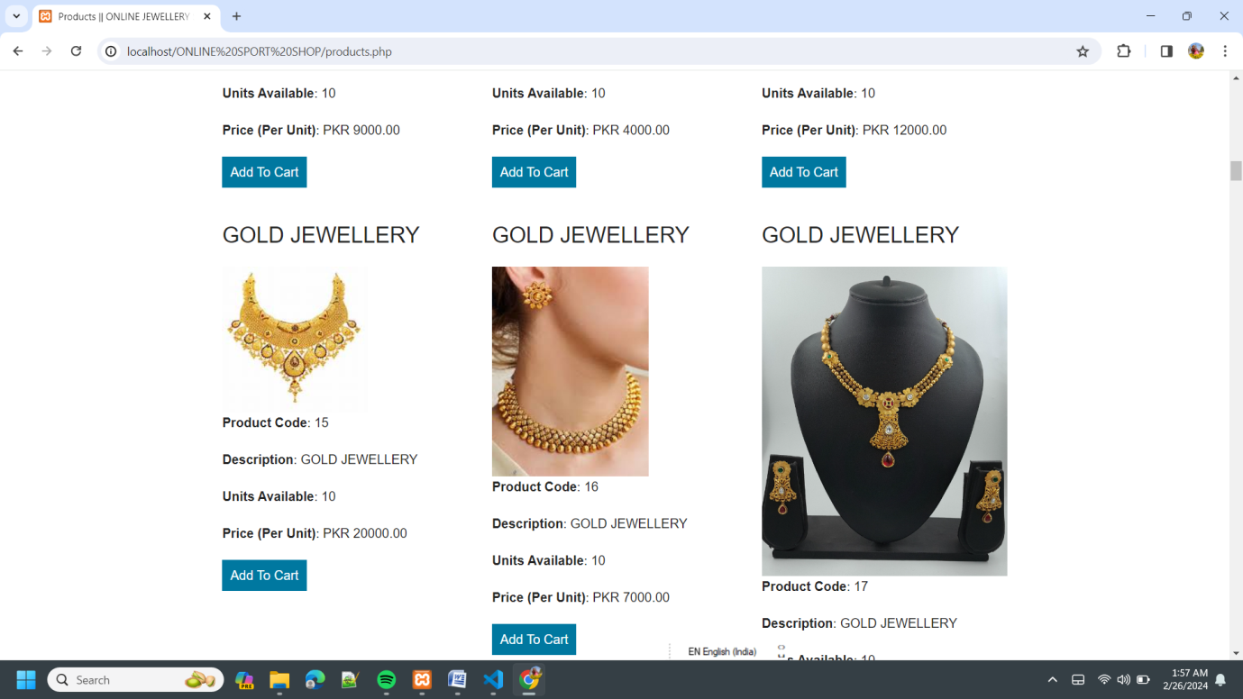

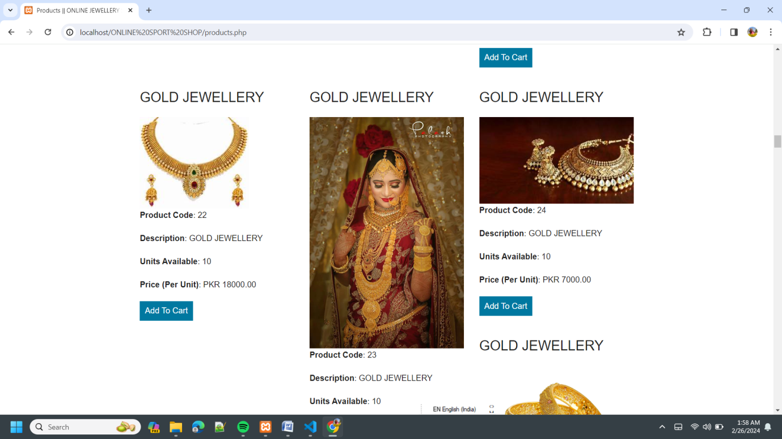

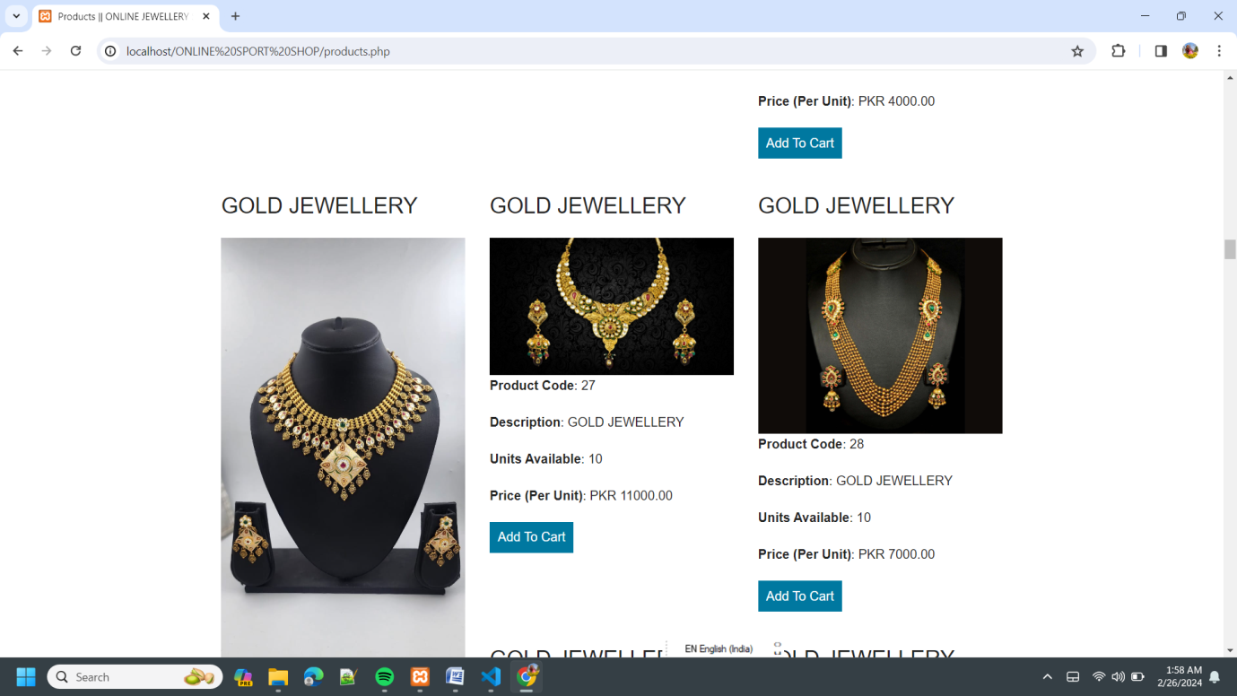

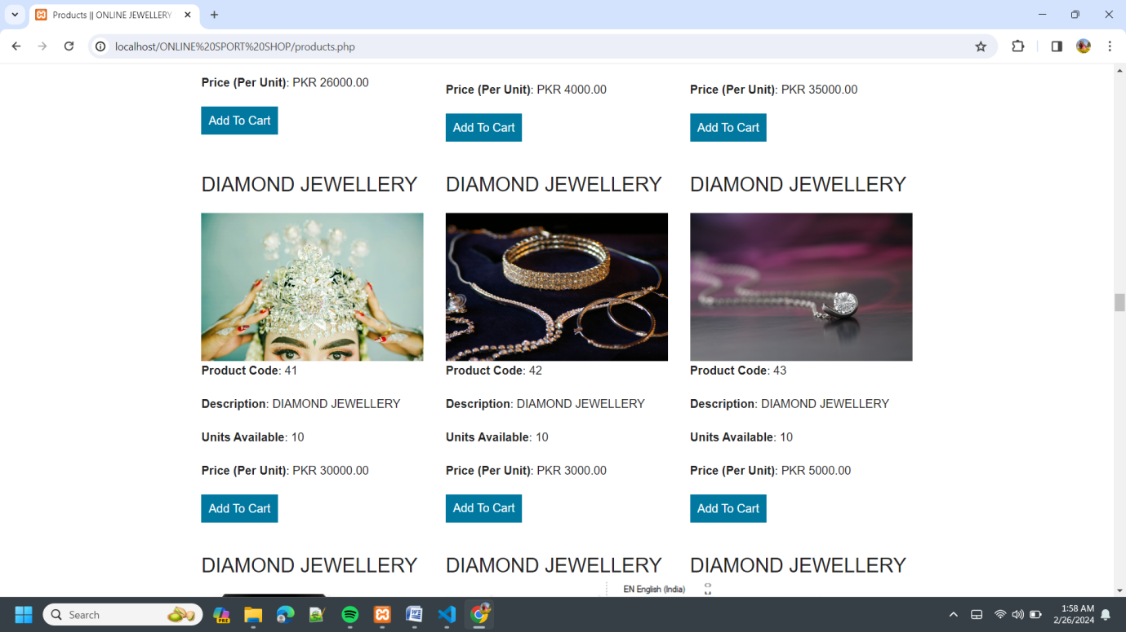

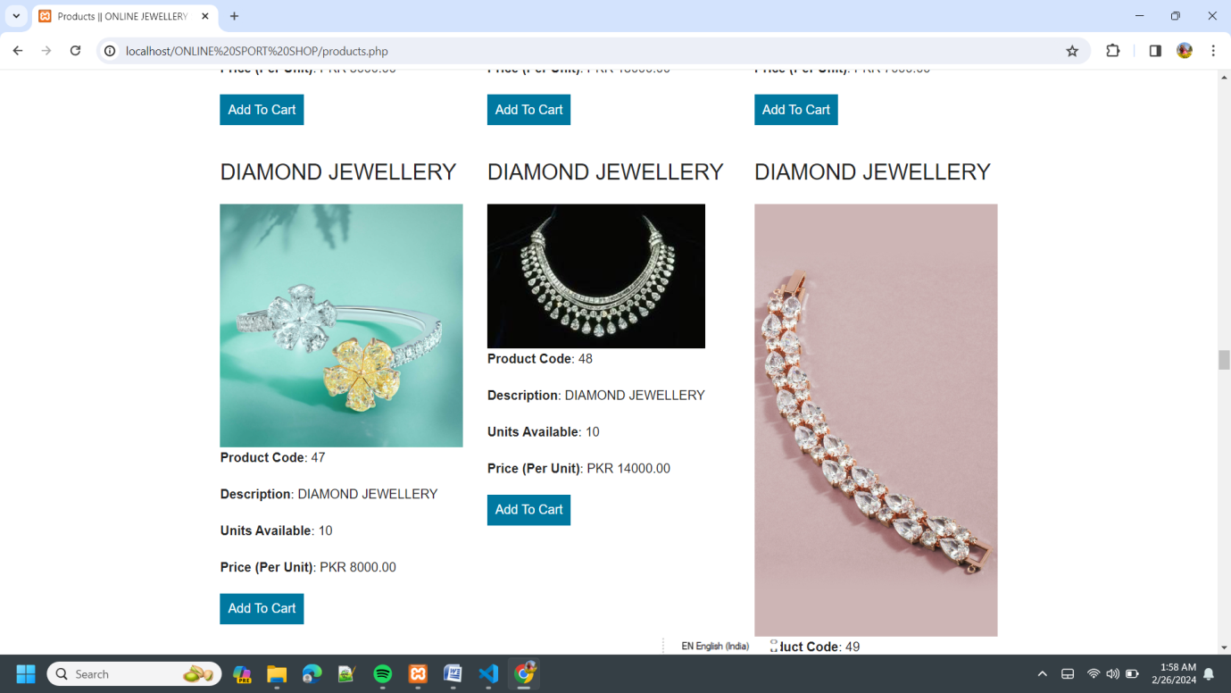

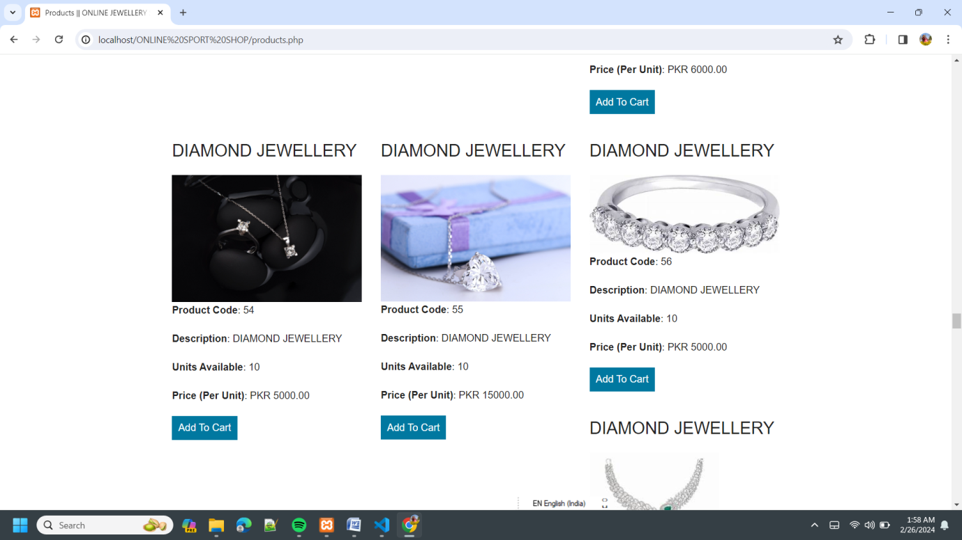

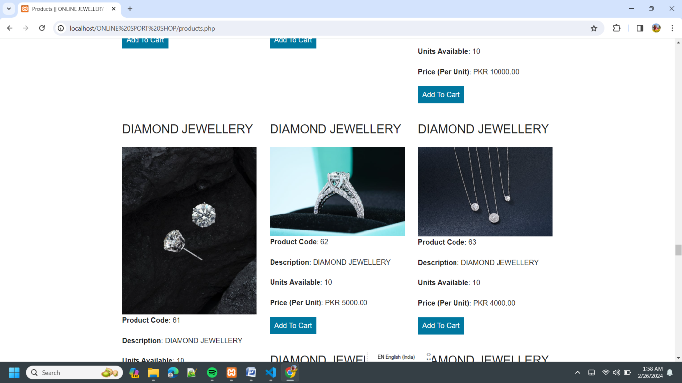

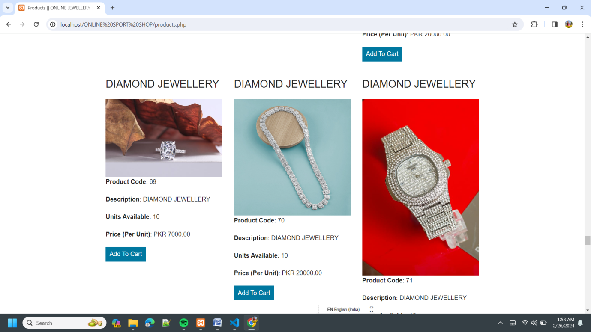

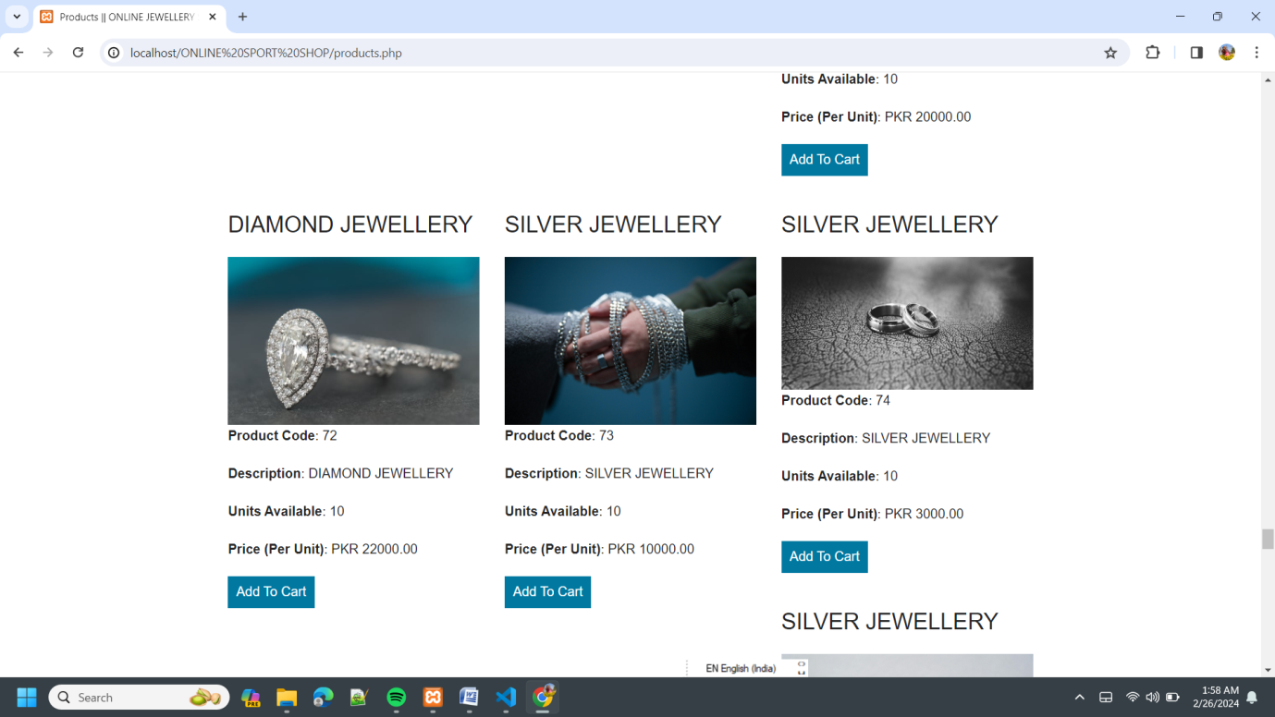

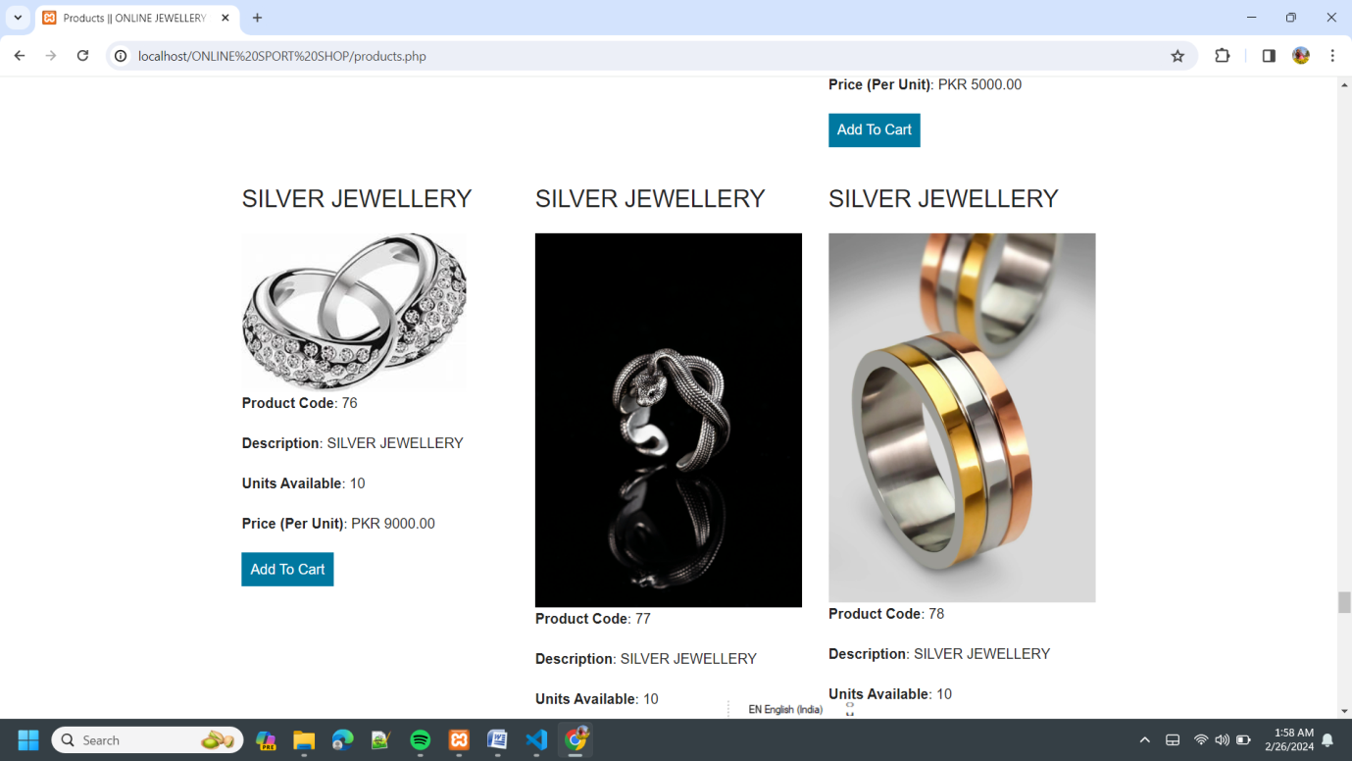

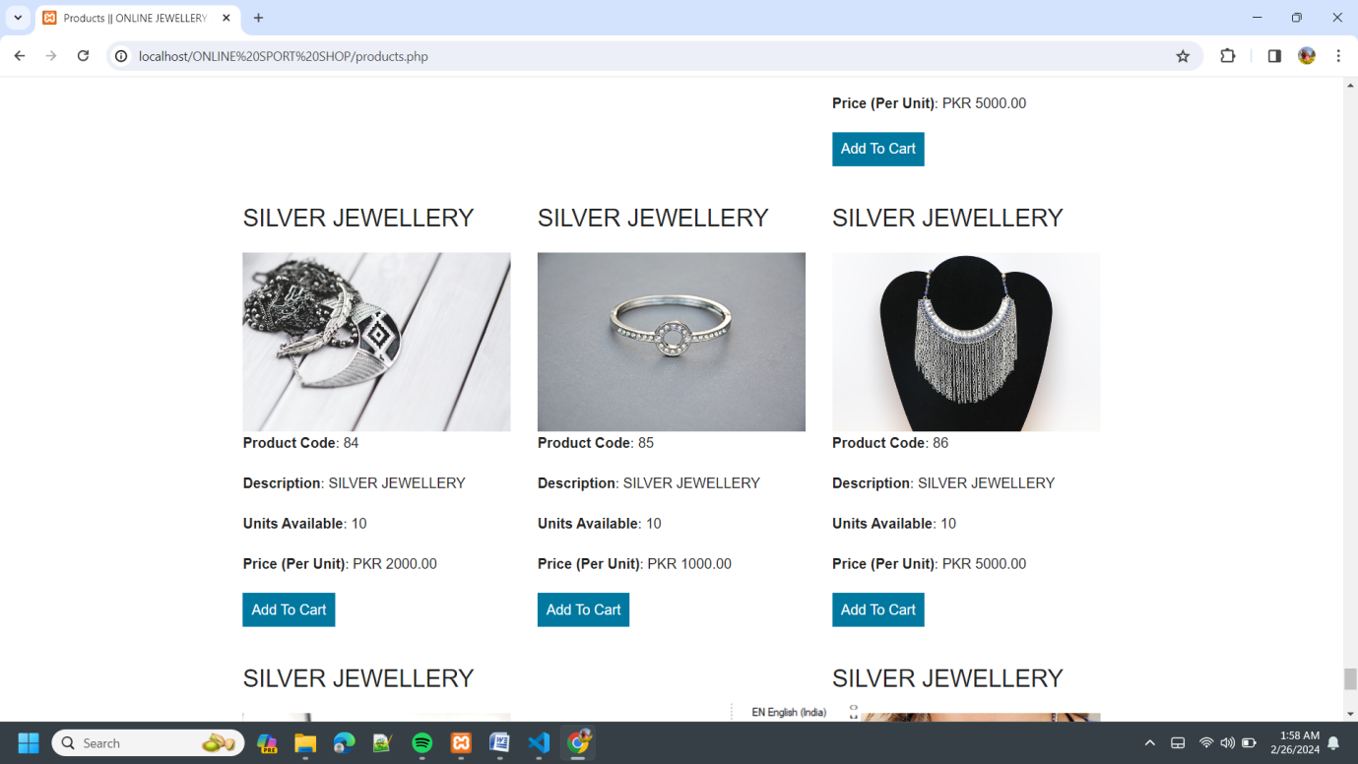

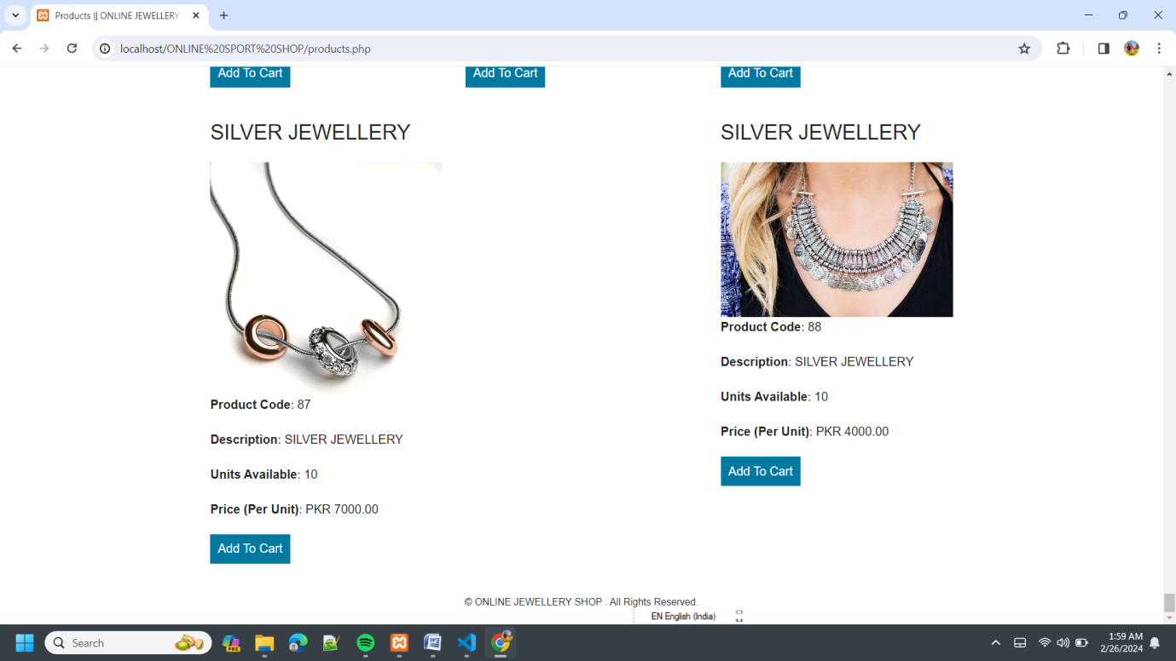

6. VIEW CART :
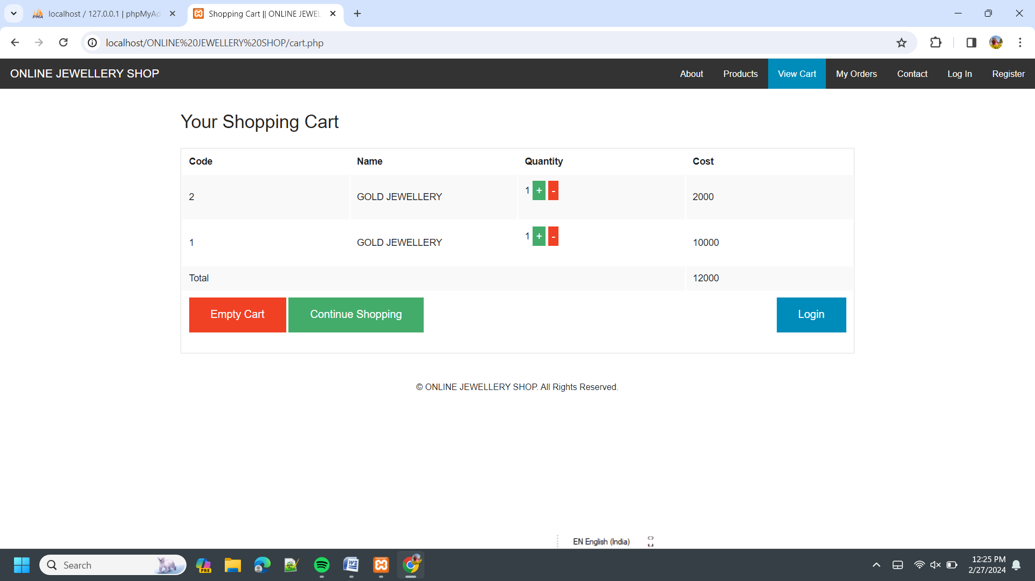

6. VALIDATION CHECKS
It provides final assurances that software meets all functional, behavioral & performance requirement. Black box testing techniques are used.
Test Cases- I have used a number of test cases for testing the product. There were different cases for which different inputs were used to check whether desired output is produced or not.
1. Addition of a new product to the cart should create a new row in the shopping cart.
2. Addition of an existing product to the cart has to update the quantity of the product.
3. Any changes to items in the cart have to update the summary correctly.
4. Because same page is inserting data into more than one table in the database atomicity of the transaction is tested.
5. The state of the system after a product has been dragged in to the cart should be same as the state of the system if the same product is added to the cart by clicking a button.

IMPLEMENTATION AND MAINTENACE
7.1 Testing
I have tested each view/module of the application individually. As the modules were built up testing was carried out simultaneously, tracking out each and every kind of input and checking the corresponding output until module is working correctly.
The functionality of the modules was also tested as separate units. Each of the three modules was tested as separate units. In each module all the functionalities were tested in isolation.
de sure that if the item already exists in the shopping cart then the quantity is increased by one else a new item is created in the shopping cart. Also the state of the system after a product has been dragged in to the shopping cart is same as the state of the system if it was added by clicking the add to cart button. Also it has been ensured that all the images of the products displayed in the shop products page are drag gable and have the product property so that they can be dropped in the cart area.
In the Product Description Module it has been tested that all the images are displayed properly. Users can add review and the as soon as a user adds a review it is updated in the view customer review tab. It has been checked to see if the whole page refreshes or a partial page update happens when a user writes a review.

7.2 Implementation
With the continuous improvement of science and technology, computer science continues to develop and its powerful features have been deeply understand that it has entered all areas of human society and play an increasingly important role.
Universities sports equipment rental system is part of a university of its content management indispensable for sports equipment managers and those who borrow sports equipment is vital, therefore, universities and sports equipment rental system should be able to users and managers to provide adequate information and inquiry means fast, but has been the use of the traditional manual management of inventory, this management approach, there are many shortcomings, such as low efficiency, confidentiality and poor, but over time, will produce a large number of files and data, which for the search, update and maintain all brought many difficulties.

With this new model, for the University to create a new educational environment that manage to break through the constraints of time, to expand the management scale, improve work efficiency and management level, so that sports equipment managers, teachers may at any time, any place through the network for management and information dissemination
The value of performance in the summary and the formation of theories and methods based on the network environment of sports equipment management system designed to optimize the management of sports equipment; explore and summarize the information age how to reform the traditional ideas and models, allowing users to learn to use network resources methods and management experience; develop universities sports equipment rental software has some practical value.
7.3 Maintenance
Universities sports equipment rental system focused on providing a simple and practical network management platform and accurate and reliable information for sports equipment managers, to provide a convenient and friendly and efficient service for sports equipment borrower.
Universities Sports equipment rental system is mainly to meet borrow sports equipment and sports equipment management needs, through the application of sports equipment rental sports equipment management system to improve management efficiency, conservation-related management costs, standardize sports equipment management tools, to form a package in line with the research and design theory of modern sports equipment management, to meet the needs of modern sports equipment development.
The theoretical value of the performance in the improvement and development of traditional sports equipment management system design theory and method.

8.SECURITY MEASURE
In the present day, technology has transformed how human beings live and the processes they use to full fill day-to-day activities. Buying and
selling has been among man’s key activities and over the years, these activities have become more sophisticated to enhance the ease and comfort of the experience.
The shopping experience, buying and selling has further transformed over the past decade with the inception of the internet.
Online shopping, and e-commerce in general, have gained popularity and provide more convenient and less stressful options transacting online. Consumers can now enjoy accessing products from distant stores according to their preference, a factor that gives consumers the ability to choose without considering distance and long queues.
While online shopping promises to be a better option to the consumer, the channel is susceptible to threats, referring to elements that have the potential to inflict serious harm on a user’s privacy leading to data breaches and a compromise of data security.
As a consequence consumers are uncertain on whether to trust online shopping. This paper includes information on the threats of online shopping and highlights consumer perceptions, including negative consumer perceptions.
The paper provides awareness on cyber security issues, including ways online shoppers and merchants can protect themselves from data breaches and attacks through methods such as phishing and adware.

9.BIBLIOGRAPHY
- During the development of project I have use the following books and websites.

- PHP
- Javascript
- Css
- HTML

- Websites:

- www.Google.com
- www.sports.com
- www.sportsenquiment.com

THANK YOU

